**OUTREACH SCHOOLS EXAMINATION BOARD**

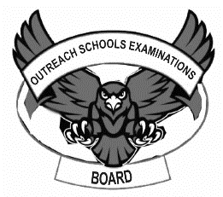**BEGINNING OF TERM III EXAMINATION 2023**

**BABY CLASS: (3 – 4 YEARS)**

**LEARNING AREA 1: SOCIAL DEVELOPMENT**

**My name is: ……………………………………………………………….**

**My School is: …………………………………….………………………..**

**I am in: ………………………………..…………………………….…………………..**

**Oral.**

1. Greet your teacher.
2. What is your name of?
3. Where do you live?
4. Who is your teacher?
5. Are you fine?
6. Are you a girl or a boy?
7. Where do you go to school?
8. How many ears do have?
9. Do these,

clap, box, ran, greet, smile, jump, dance, write

1. **Show me your,**

face, eyes, nose legs, hands, neck.

1. **Draw the domestic animals.**

|  |  |
| --- | --- |
|  |  |
| **cat** | **dog** |
|  |  |
| **cow** | **pig** |

1. **Colour**

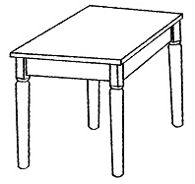

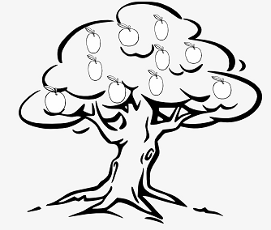 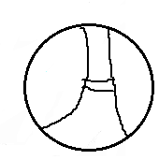

1. **Match to the belonging.**

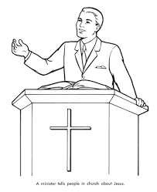

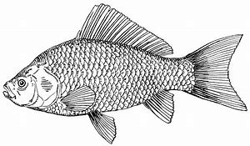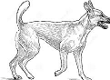 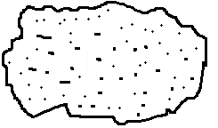



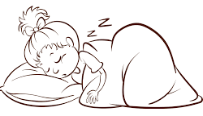 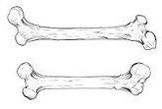

 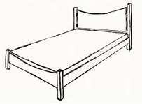

**End**